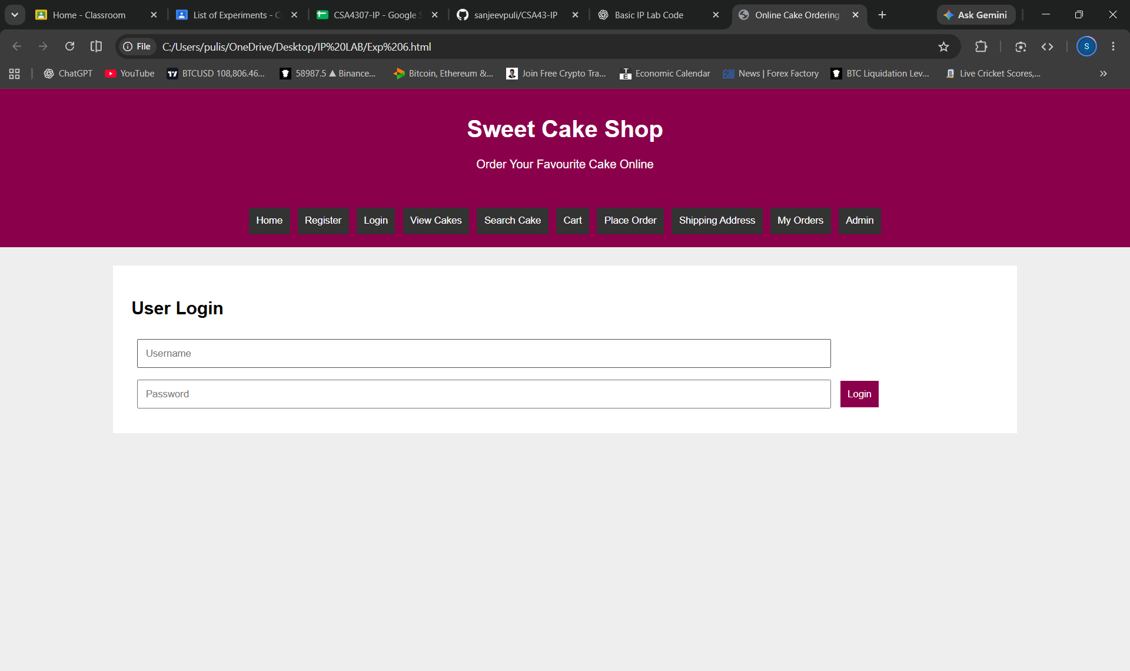
<!DOCTYPE html>
<html>
<head>
<title>Online Cake Ordering System</title>
<style>
body{font-family:Arial;margin:0;background:#eee}
header,nav{background:#8b004b;color:white;text-align:center;padding:15px}
nav button{background:#333;color:white;border:0;padding:10px;margin:3px;cursor:pointer}
.box{background:white;margin:25px auto;padding:25px;width:80%;box-sizing:border-box}
input,select,textarea{padding:10px;margin:8px;width:80%;box-sizing:border-box}
button{padding:10px;background:#8b004b;color:white;border:0;cursor:pointer}
.page{display:none}
#home{display:block}
.cake{display:inline-block;background:#ffe6f0;padding:15px;margin:10px;width:150px}
</style>
</head>
<body>

<header>
<h1>Sweet Cake Shop</h1>
<p>Order Your Favourite Cake Online</p>
</header>

<nav>
<button onclick="show('home')">Home</button>
<button onclick="show('register')">Register</button>
<button onclick="show('login')">Login</button>
<button onclick="show('cakes')">View Cakes</button>
<button onclick="show('search')">Search Cake</button>
<button onclick="show('cart')">Cart</button>
<button onclick="show('order')">Place Order</button>
<button onclick="show('address')">Shipping Address</button>
<button onclick="show('myorder')">My Orders</button>
<button onclick="show('admin')">Admin</button>
</nav>

<div class="box page" id="home">
<h2>Welcome to Sweet Cake Shop</h2>
<p>Choose your favourite cake and order online.</p>
</div>

<div class="box page" id="register">
<h2>Student Registration</h2>
<input placeholder="Full Name">
<input type="email" placeholder="Email">
<input type="password" placeholder="Password">
<button onclick="alert('Registration successful')">Register</button>
</div>

<div class="box page" id="login">
<h2>User Login</h2>
<input placeholder="Username">
<input type="password" placeholder="Password">
<button onclick="alert('Login submitted')">Login</button>
</div>

<div class="box page" id="cakes">
<h2>Available Cakes</h2>
<div class="cake">
<h3>Chocolate Cake</h3>
<p>₹500</p>
<button onclick="addCart('Chocolate Cake',500)">Add to Cart</button>
</div>
<div class="cake">
<h3>Black Forest</h3>
<p>₹600</p>
<button onclick="addCart('Black Forest',600)">Add to Cart</button>
</div>
<div class="cake">
<h3>Vanilla Cake</h3>
<p>₹400</p>
<button onclick="addCart('Vanilla Cake',400)">Add to Cart</button>
</div>
<div class="cake">
<h3>Strawberry Cake</h3>
<p>₹550</p>
<button onclick="addCart('Strawberry Cake',550)">Add to Cart</button>
</div>
</div>

<div class="box page" id="search">
<h2>Search and Filter Cakes</h2>
<input id="keyword" placeholder="Search Cake">
<select id="category">
<option>All Categories</option>
<option>Chocolate</option>
<option>Fruit</option>
<option>Vanilla</option>
</select>
<select id="price">
<option>All Prices</option>
<option>Below ₹500</option>
<option>₹500 and Above</option>
</select>
<button onclick="searchCake()">Search</button>
<p id="searchResult"></p>
</div>

<div class="box page" id="cart">
<h2>Shopping Cart</h2>
<p id="cartItems">Your cart is empty.</p>
<p id="total">Total: ₹0</p>
</div>

<div class="box page" id="order">
<h2>Place Order</h2>
<input id="customer" placeholder="Customer Name">
<input id="cakeSize" placeholder="Cake Size (e.g. 1 kg)">
<input id="message" placeholder="Cake Message">
<button onclick="placeOrder()">Confirm Order</button>
<p id="orderResult"></p>
</div>

<div class="box page" id="address">
<h2>Shipping Address</h2>
<input id="addressName" placeholder="Full Name">
<input id="phone" placeholder="Phone Number">
<textarea id="shipping" placeholder="Delivery Address"></textarea>
<button onclick="saveAddress()">Save Address</button>
<p id="addressResult"></p>
</div>

<div class="box page" id="myorder">
<h2>My Orders</h2>
<p id="myOrderResult">No orders placed yet.</p>
</div>

<div class="box page" id="admin">
<h2>Admin Panel</h2>
<input id="cakeName" placeholder="Cake Name">
<input id="cakePrice" type="number" placeholder="Cake Price">
<button onclick="addCake()">Add Cake</button>
<p id="adminResult"></p>
</div>

<script>
let cart=[];
let orderDetails="";

function show(id){
document.querySelectorAll('.page').forEach(p=>p.style.display='none');
document.getElementById(id).style.display='block';
}

function addCart(name,price){
cart.push({name,price});
updateCart();
alert(name+' added to cart');
}

function updateCart(){
let items=cart.map(c=>c.name+' - ₹'+c.price).join(', ');
let total=cart.reduce((sum,c)=>sum+c.price,0);
document.getElementById('cartItems').innerText=items||'Your cart is empty.';
document.getElementById('total').innerText='Total: ₹'+total;
}

function searchCake(){
let k=document.getElementById('keyword').value.toLowerCase();
let c=document.getElementById('category').value;
let p=document.getElementById('price').value;
let result='Chocolate Cake ₹500, Black Forest ₹600, Vanilla Cake ₹400, Strawberry Cake ₹550';
if(k) result=result.toLowerCase().includes(k)?'Matching cakes found. Check View Cakes.':'No cakes found.';
if(c!=='All Categories') result='Selected category: '+c;
if(p!=='All Prices') result='Selected price range: '+p;
document.getElementById('searchResult').innerText=result;
}

function placeOrder(){
let name=document.getElementById('customer').value;
let size=document.getElementById('cakeSize').value;
if(!name||cart.length===0){
alert('Enter your name and add a cake to cart');
return;
}
orderDetails='Order ID: '+Math.floor(1000+Math.random()*9000)+
' | Customer: '+name+' | Size: '+size+
' | Total: ₹'+cart.reduce((s,c)=>s+c.price,0);
document.getElementById('orderResult').innerText='Order placed successfully!';
document.getElementById('myOrderResult').innerText=orderDetails;
cart=[];
updateCart();
}

function saveAddress(){
let a=document.getElementById('shipping').value;
document.getElementById('addressResult').innerText=
a?'Shipping address saved successfully':'Enter delivery address';
}

function addCake(){
let n=document.getElementById('cakeName').value;
let p=document.getElementById('cakePrice').value;
document.getElementById('adminResult').innerText=
n&&p?'Cake Added: '+n+' | Price: ₹'+p:'Enter cake name and price';
}
</script>

</body>
</html>

